HANDLE Introductory and Basics Course (Levels 1-2)
Course Description
“I am seriously impressed. This work touches the nerve of virtually everything taking place in our current cultural crisis of childhood.” - Joseph Chilton Pearce, author: Magical Child, & other books
- This course will forever change your strategies when approaching learning, social and behavioral challenges!
- You will begin to interpret the real reasons for behaviors and understand causes of learning difficulties, inefficiency or stress.
- You will learn how body and brain work together and how the environment may influence human functioning.
- You will learn ways to support learning, reduce stress, prevent crises, enhance potential and foster resilience.
- You will leave with tools and knowledge to apply in everyday situations.
- You will see yourself and others through non-judgmental eyes that will open new doors of possibility!
- You will have made the first step toward the possibility of becoming a HANDLE provider.
The course explores how irregularities in neurological and developmental systems relate to perplexing behaviors and dysfunction and offers activities, strategies and compensations to reduce stress and improve function.
Course Content: (Note: Level 1 is prerequisite to Level 2)
∎ Understanding the HANDLE principles and their application (Level 1)
●The science of how stress affects learning and quality of life (Level 1)
∎Understanding how nutrition and good health enhance our abilities (Level 1)
∎ Learning to notice signs of stress and intervene before the consequences manifest (Level 1-2)
∎ Discovering how our quality of life and abilities are affected by internal and external environment (Level 1-2)
● Learning about Gentle Enhancement® and the meaning of “innocent assault” (Level 1-2)
● Discovering root causes of challenging behaviors and learning difficulties (Level 2)
● Creating a new understanding of the senses and motor functions (Level 2)
● Understanding and interpreting learning, social and behavioral challenges (Level 2)
● Exploring the neurodevelopmental systems - the building blocks of learning and achievement (Level 2)
● Discovering the elements of learning – such as the numerous systemic influences on writing (Level 2)
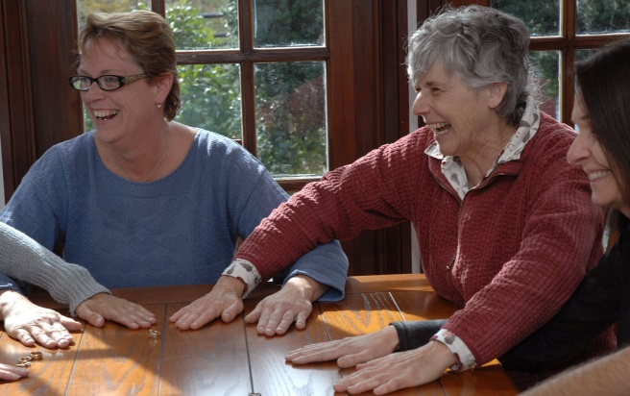
● Learning how to positively enhance learning without overwhelm (Level 2)
● Learning how neurodevelopmental systems develop, affect and support each other (Level 2)

HANDLE Activities for enhancing learning and human potential
● Learn 11 HANDLE Activities (5 in Level 1 and 6 in Level 2).
● Explore a wide range of variations and applications for each of the activities.
● Learn examples of HANDLE in action.

Most often stated feedback following HANDLE courses: “Everyone should know this!”

